SIMATS ENGINEERING
ASSESSMENT TOOL 1

COURSE NAME: INTERNET PROGRAMMING
COURSE CODE: CSA4307

COURSE OUTCOME COVERED

CO 3: Implement dynamic web applications by utilizing DOM-based client-side scripting and employing Java Servlets for server-side request processing and response handling. (L3)

Assessment Tool : Scenario-Based Assessment

Weightage: 40%
Dr. V. Parthipan

QUESTIONS: Total Marks: 30

Question 1
Suppose that a college wants to develop an online student registration system where students submit their details through a web form, and the data is processed using a Java Servlet.
Explain the architecture of a servlet-based application. Design and implement a servlet to handle form data using both GET and POST methods. Describe the servlet life cycle (init, service, destroy) and justify which method is more appropriate for handling sensitive data.

Question 2
Suppose that a website requires users to log in and maintain their session across multiple pages after authentication.
Design a session management system using HttpSession and Cookies in Servlets. Explain how session tracking works in web applications and compare session-based tracking with cookies.

Question 3
Suppose that an e-commerce platform needs to store and retrieve product details from a database using a Java-based web application.
Design a JDBC-based application to connect to a database, insert product data, and retrieve it using SQL queries. Explain the JDBC architecture and describe the steps involved in database connectivity along with proper exception handling.

Code of Conduct:

I __G. Srivalli (192365014) _ (Name / Reg No) certify that this submission is my original work and that I have adhered to the guidelines specified for this assessment.
I understand that any violation of academic integrity rules will result in disciplinary action.

Signature of the student:


RUBRICS FOR CALCULATION:

Criteria | Weightage (%) | Level 4 (Exemplary) | Level 3 (Proficient) | Level 2 (Developing) | Level 1 (Beginning)
Understanding of Scenario | 20% | Demonstrates clear and complete understanding of the scenario and context | Shows good understanding with minor gaps | Partial understanding; misses key aspects | Misinterprets or fails to understand the scenario
Identification of Key Issues | 20% | Accurately identifies all relevant issues and factors involved | Identifies most key issues with minor omissions | Identifies limited issues; some irrelevant points | Unable to identify key issues
Application of Concepts | 25% | Applies appropriate concepts effectively to address the scenario | Applies concepts with minor errors | Limited or partially correct application | Unable to apply relevant concepts
Decision Making | 20% | Makes well-reasoned, logical decisions with strong rationale | Makes reasonable decisions with some justification | Makes weak decisions with limited justification | No clear decisions made or rationale provided
Clarity of Response | 15% | Response is clear, structured, and logically presented | Generally clear with minor issues | Somewhat unclear or poorly structured | Disorganized and difficult to understand

Question 1: Online Student Registration System
1. Architecture of a Servlet-Based Application
A servlet-based web application follows a standard Three-Tier / Client-Server Web Architecture:
- Client Tier (Presentation Layer): A web browser renders HTML forms and captures user input.
- Server/Application Tier (Servlet Container / Web Tier): A web server paired with a Servlet Container (such as Apache Tomcat, Eclipse Jetty, or GlassFish) manages the lifecycle of servlets, parses incoming HTTP requests into HttpServletRequest objects, and constructs HttpServletResponse objects.
- Data Tier (Backend Layer): A persistent storage engine (such as MySQL or PostgreSQL) accessed via JDBC.
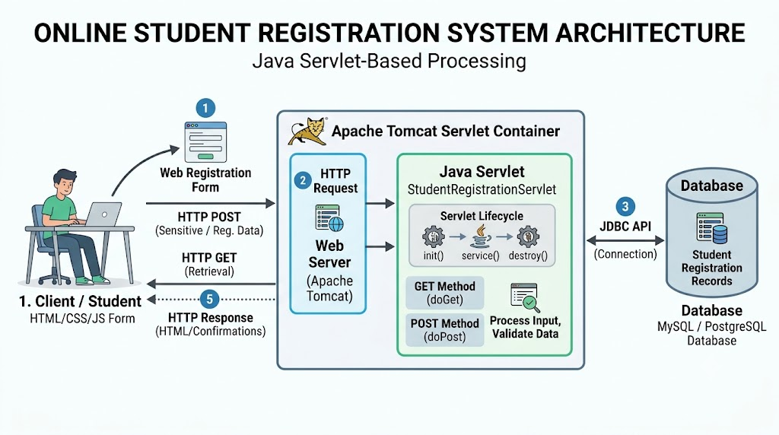

Communication Flow
- The student completes an HTML registration form and clicks Submit.
- The browser packages form fields into an HTTP request (GET query string or POST message body) directed to the servlet’s mapped URL pattern (e.g., /register).
- The Web Server receives the socket connection and delegates it to the Servlet Container.
- The container allocates or assigns a worker thread from its thread pool, instantiates/reuses the target servlet, and invokes service(HttpServletRequest request, HttpServletResponse response).
- The service() method inspects the HTTP method token and routes execution to doGet() or doPost().
- The servlet extracts parameters, applies business logic or database operations, generates dynamic HTML/JSON, flushes the output stream, and terminates the thread execution.
2. Design and Implementation: HTML Form & Registration Servlet
HTML Registration Form (register.html)
HTML
<!DOCTYPE html>
<html lang="en">
<head>
<meta charset="UTF-8">
<title>Student Registration System</title>
</head>
<body>
<h2>Online Student Registration</h2>
<!-- Uses POST for secure submission of personal details -->
<form action="StudentRegistrationServlet" method="POST">
<label for="studentId">Student ID:</label><br>
<input type="text" id="studentId" name="studentId" required><br><br>
<label for="studentName">Full Name:</label><br>
<input type="text" id="studentName" name="studentName" required><br><br>
<label for="email">Email Address:</label><br>
<input type="email" id="email" name="email" required><br><br>
<label for="department">Department:</label><br>
<select id="department" name="department">
<option value="Computer Science">Computer Science</option>
<option value="Information Technology">Information Technology</option>
<option value="Electronics">Electronics</option>
</select><br><br>

<label for="password">Portal Password:</label><br>
<input type="password" id="password" name="password" required><br><br>
<input type="submit" value="Register Student">
</form>
</body>
</html>
Java Servlet Implementation (StudentRegistrationServlet.java)
Java
package com.simats.registration;
import java.io.IOException;
import java.io.PrintWriter;
import jakarta.servlet.ServletException;
import jakarta.servlet.annotation.WebServlet;
import jakarta.servlet.http.HttpServlet;
import jakarta.servlet.http.HttpServletRequest;
import jakarta.servlet.http.HttpServletResponse;
@WebServlet("/StudentRegistrationServlet")
public class StudentRegistrationServlet extends HttpServlet {
private static final long serialVersionUID = 1L;
@Override
public void init() throws ServletException {
// One-time initialization logic (e.g., logging or resource allocation)
System.out.println("StudentRegistrationServlet initialized.");
}
// Handles query/read requests (e.g., checking registration status or instructions)
@Override
protected void doGet(HttpServletRequest request, HttpServletResponse response)
throws ServletException, IOException {
response.setContentType("text/html;charset=UTF-8");
try (PrintWriter out = response.getWriter()) {
String queryId = request.getParameter("studentId");
out.println("<!DOCTYPE html><html><head><title>Registration Info</title></head><body>");
if (queryId != null && !queryId.trim().isEmpty()) {
out.println("<h3>Checking status for Student ID: " + queryId + "</h3>");
out.println("<p>Status: Verification Pending.</p>");
} else {
out.println("<h3>Student Registration Portal</h3>");
out.println("<p>Please submit the registration form using the official portal.</p>");
}
out.println("</body></html>");
}
}
// Handles form data submission (creates/updates registration state)
@Override
protected void doPost(HttpServletRequest request, HttpServletResponse response)
throws ServletException, IOException {
response.setContentType("text/html;charset=UTF-8");
// Extracting form fields
String studentId = request.getParameter("studentId");
String studentName = request.getParameter("studentName");
String email = request.getParameter("email");
String department = request.getParameter("department");
String password = request.getParameter("password"); // Sensitive field
try (PrintWriter out = response.getWriter()) {
out.println("<!DOCTYPE html><html><head><title>Registration Confirmation</title></head><body>");
// Server-side validation
if (studentId == null || studentName == null || password == null ||
studentId.trim().isEmpty() || studentName.trim().isEmpty() || password.isEmpty()) {
out.println("<h3 style='color:red;'>Error: Missing mandatory registration fields.</h3>");
out.println("<a href='register.html'>Back to Form</a>");
} else {
// In production, delegate to a DAO layer to persist data securely
out.println("<h2 style='color:green;'>Registration Successful!</h2>");
out.println("<p><strong>Student ID:</strong> " + studentId + "</p>");
out.println("<p><strong>Name:</strong> " + studentName + "</p>");
out.println("<p><strong>Email:</strong> " + email + "</p>");
out.println("<p><strong>Department:</strong> " + department + "</p>");
out.println("<p><em>Password securely received and hashed for storage.</em></p>");
}
out.println("</body></html>");
}
}
@Override
public void destroy() {
// Cleanup resources before servlet is removed by the container
System.out.println("StudentRegistrationServlet destroyed.");
}
}
3. Servlet Life Cycle
The life cycle of a servlet is managed entirely by the servlet container through three core methods:
- init(ServletConfig config):
  - Invoked once when the servlet is first loaded into memory (either upon the first request or at container startup if <load-on-startup> is configured).
  - Used for heavy one-time initialization, such as opening shared resources or reading configuration settings.
- service(ServletRequest req, ServletResponse res):
  - Invoked for every incoming client request.
  - Runs in a separate worker thread within the container's thread pool.
  - Dispatches execution to HTTP-specific handlers (doGet, doPost, doPut, doDelete) in HttpServlet.
- destroy():
  - Invoked once before the servlet instance is deallocated from memory by the container (e.g., during application undeploy or server shutdown).
  - Used to release open database connections, stop background threads, and flush buffers.
4. Method Justification for Handling Sensitive Data: POST vs. GET
Evaluation Parameter | HTTP GET | HTTP POST
Data Placement | Appended to the URL in the query string (?key=val) | Embedded within the HTTP Request Message Body
Visibility / Security | Highly visible in address bar, browser history, proxy logs, and Referer headers | Hidden from URLs, logs, and browser history
Payload Size Limit | Severely restricted by URI length limits (~2048 characters depending on browser/server) | Virtually unlimited (configurable by server)
Idempotency & Caching | Idempotent, safe, and cached by default | Non-idempotent; not cached by default

Verdict: HTTP POST is the required method for student registration. Because the form collects sensitive attributes—specifically passwords, personal email addresses, and identification numbers—transmitting them via GET would expose raw credentials in browser histories, web server access logs, and intermediate proxy caches. POST, especially when wrapped in TLS/HTTPS, encapsulates the payload inside an encrypted request body.
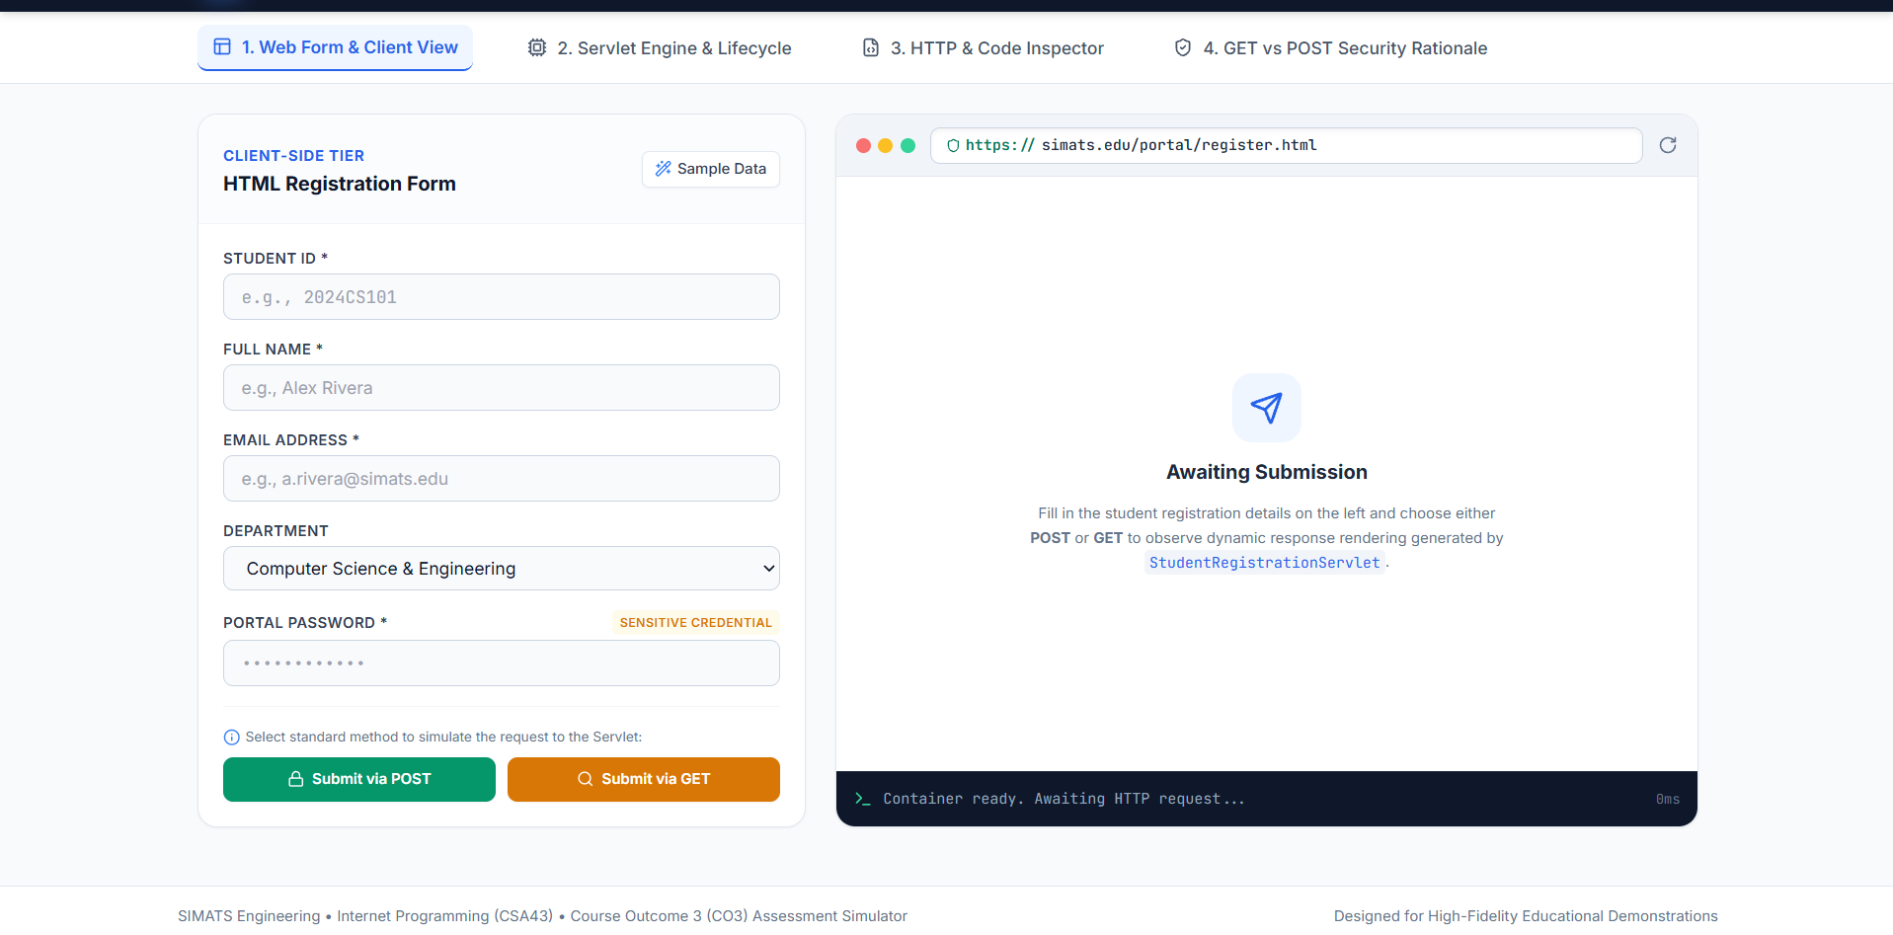

Question 2: Session Management System
1. How Session Tracking Works in Web Applications
HTTP is a stateless protocol: every request-response cycle is completely independent, and the server retains no built-in memory of prior requests from the same client.
To maintain state across multiple page interactions (e.g., keeping a user logged in), web applications use Session Tracking:
- When a client authenticates successfully, the server creates a unique session record in its memory or persistent cache.
- The server generates a globally unique identifier (e.g., JSESSIONID).
- This identifier is sent back to the client, typically via a Set-Cookie HTTP header.
- On subsequent requests, the client automatically attaches this identifier via the Cookie request header.
- The container matches the incoming token against its active session table to retrieve the associated user state.
2. Design and Implementation: Login, Dashboard, and Logout
A. Authentication Servlet (LoginServlet.java)
Java
package com.simats.session;
import java.io.IOException;
import java.io.PrintWriter;
import jakarta.servlet.ServletException;
import jakarta.servlet.annotation.WebServlet;
import jakarta.servlet.http.Cookie;
import jakarta.servlet.http.HttpServlet;
import jakarta.servlet.http.HttpServletRequest;
import jakarta.servlet.http.HttpServletResponse;
import jakarta.servlet.http.HttpSession;
@WebServlet("/LoginServlet")
public class LoginServlet extends HttpServlet {
private static final long serialVersionUID = 1L;
@Override
protected void doPost(HttpServletRequest request, HttpServletResponse response)
throws ServletException, IOException {
String username = request.getParameter("username");
String role = request.getParameter("role"); // e.g., "Student" or "Faculty"
// Mock authentication check
if (username != null && !username.trim().isEmpty()) {
// 1. Establish HttpSession on the server side
HttpSession session = request.getSession(true); // Create new session
session.setAttribute("currentUser", username);
session.setAttribute("userRole", role != null ? role : "Student");
session.setMaxInactiveInterval(15 * 60); // 15-minute timeout
// 2. Establish a client-side tracking cookie (e.g., theme or visit count)
Cookie userPreferenceCookie = new Cookie("userTheme", "Dark");
userPreferenceCookie.setMaxAge(7 * 24 * 60 * 60); // Persist for 7 days
userPreferenceCookie.setHttpOnly(true); // Prevent XSS access
userPreferenceCookie.setPath("/"); // Global scope
response.addCookie(userPreferenceCookie);
// Redirect to protected dashboard
response.sendRedirect("DashboardServlet");
} else {
response.setContentType("text/html");
PrintWriter out = response.getWriter();
out.println("<p style='color:red;'>Invalid credentials. <a href='login.html'>Try again</a></p>");
}
}
}
B. Protected Resource Servlet (DashboardServlet.java)
Java
package com.simats.session;
import java.io.IOException;
import java.io.PrintWriter;
import jakarta.servlet.ServletException;
import jakarta.servlet.annotation.WebServlet;
import jakarta.servlet.http.Cookie;
import jakarta.servlet.http.HttpServlet;
import jakarta.servlet.http.HttpServletRequest;
import jakarta.servlet.http.HttpServletResponse;
import jakarta.servlet.http.HttpSession;
@WebServlet("/DashboardServlet")
public class DashboardServlet extends HttpServlet {
private static final long serialVersionUID = 1L;
@Override
protected void doGet(HttpServletRequest request, HttpServletResponse response)
throws ServletException, IOException {
response.setContentType("text/html;charset=UTF-8");
// Validate session without creating a new one
HttpSession session = request.getSession(false);
if (session == null || session.getAttribute("currentUser") == null) {
// Unauthorized access; redirect to login
response.sendRedirect("login.html");
return;
}
String username = (String) session.getAttribute("currentUser");
String role = (String) session.getAttribute("userRole");
// Read client-side cookie
String theme = "Default";
Cookie[] cookies = request.getCookies();
if (cookies != null) {
for (Cookie c : cookies) {
if ("userTheme".equals(c.getName())) {
theme = c.getValue();
break;
}
}
}

try (PrintWriter out = response.getWriter()) {
out.println("<!DOCTYPE html><html><head><title>Dashboard</title></head><body>");
out.println("<h1>Welcome to your Dashboard, " + username + "!</h1>");
out.println("<p><strong>Assigned Role:</strong> " + role + "</p>");
out.println("<p><strong>Session ID:</strong> " + session.getId() + "</p>");
out.println("<p><strong>Active Theme (from Cookie):</strong> " + theme + "</p>");
out.println("<br><a href='LogoutServlet'>Log Out</a>");
out.println("</body></html>");
}
}
}
C. Session Invalidation Servlet (LogoutServlet.java)
Java
package com.simats.session;
import java.io.IOException;
import jakarta.servlet.ServletException;
import jakarta.servlet.annotation.WebServlet;
import jakarta.servlet.http.Cookie;
import jakarta.servlet.http.HttpServlet;
import jakarta.servlet.http.HttpServletRequest;
import jakarta.servlet.http.HttpServletResponse;
import jakarta.servlet.http.HttpSession;
@WebServlet("/LogoutServlet")
public class LogoutServlet extends HttpServlet {
private static final long serialVersionUID = 1L;
@Override
protected void doGet(HttpServletRequest request, HttpServletResponse response)
throws ServletException, IOException {
// 1. Invalidate Server-Side Session
HttpSession session = request.getSession(false);
if (session != null) {
session.invalidate();
}
// 2. Clear Client-Side Tracking Cookies
Cookie killCookie = new Cookie("userTheme", "");
killCookie.setMaxAge(0); // Immediately delete cookie from browser
killCookie.setPath("/");
response.addCookie(killCookie);
// Redirect back to login page
response.sendRedirect("login.html");
}
}

3. Comparison: Session-Based Tracking (HttpSession) vs. Cookies
Feature | HttpSession (Server-Side) | Cookies (Client-Side)
Storage Location | Server memory / distributed cache (Redis, DB) | Client machine (browser cache / text file)
Data Capacity | Effectively unlimited (bounded by server RAM) | Limited to 4 KB per cookie, max ~20-50 per domain
Data Types Supported | Any arbitrary Java Object (Object, List, Map) | Text/Strings only
Security | High. Data stays on server; client holds only the token | Low to Moderate. Exposed to tampering unless encrypted and protected with HttpOnly and Secure flags
Network Overhead | Low. Only the session ID transmits across requests | Higher. Cookie payload is sent in full on every HTTP request header
Lifecycle / Expiry | Managed by server inactivity timeout (session.setMaxInactiveInterval()) | Managed by explicit expiry date (cookie.setMaxAge()); persists across browser restarts
Primary Use Cases | Authentication states, shopping carts, role permissions | Tracking preferences, analytics, "Remember Me" tokens

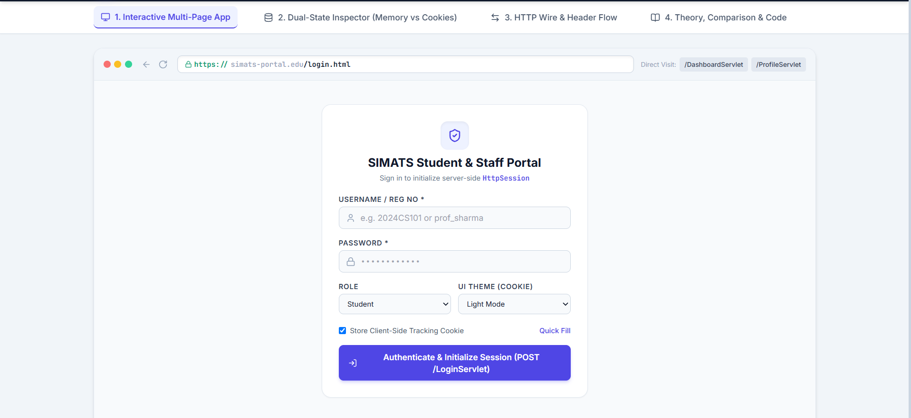
Question 3: JDBC-Based E-Commerce Application
1. JDBC Architecture
Java Database Connectivity (JDBC) is an industry-standard Java API that enables Java applications to interact with relational database management systems (RDBMS) in a database-independent manner.

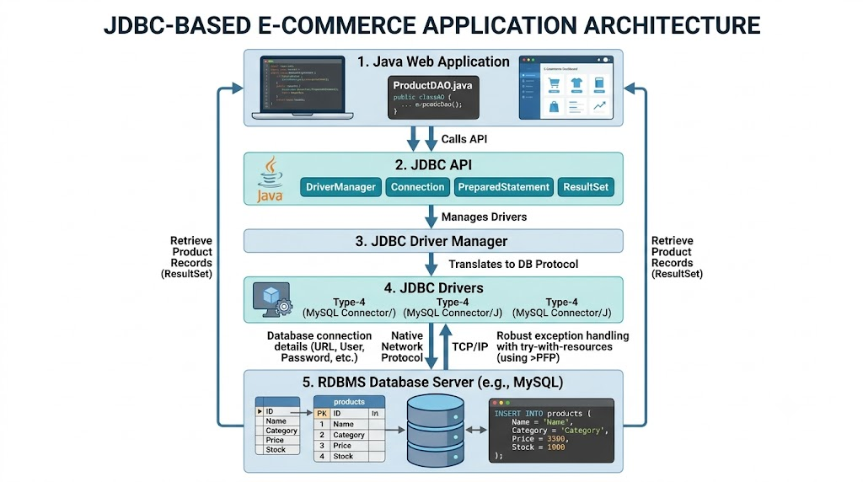

Architectural Components
- Application Layer: Calls standard JDBC interfaces to execute queries and process results.
- JDBC API: Set of built-in Java abstractions (Connection, Statement, PreparedStatement, ResultSet, CallableStatement).
- JDBC Driver Manager: Dispatches database-specific connection requests to the registered database driver.
- JDBC Drivers: Vendor-supplied client libraries implementing the standard JDBC interfaces. In modern production, Type 4 (Pure Java Native-Protocol Driver) is standard because it converts JDBC calls directly into vendor-specific database protocols without requiring native client libraries.
2. Standard Steps in Database Connectivity
Connecting and executing queries via JDBC follows six distinct steps:
- Load/Register Driver: Register the vendor's driver class (handled automatically via SPI in modern JDBC 4.0+ via META-INF/services/java.sql.Driver, or manually loaded using Class.forName("com.mysql.cj.jdbc.Driver")).
- Establish Connection: Obtain a physical socket connection using DriverManager.getConnection(url, user, password) or a connection pool (DataSource).
- Create Statement: Formulate parameterized SQL commands using PreparedStatement to prevent SQL Injection and pre-compile execution plans.
- Execute Query / Update: Execute the command using executeQuery() (for SELECT) or executeUpdate() (for INSERT, UPDATE, DELETE).
- Process Results: Iterate over the returned ResultSet using a cursor-driven loop (while(rs.next())).
- Close Resources: Release database locks and memory handles via Java's try-with-resources block (ensuring AutoCloseable execution in reverse order of creation: ResultSet $→$ PreparedStatement $→$ Connection).
3. Implementation: Product Data Operations (ProductDAO.java)
Database Schema
SQL
CREATE DATABASE ecommerce_db;
USE ecommerce_db;
CREATE TABLE products (
product_id INT PRIMARY KEY AUTO_INCREMENT,
product_name VARCHAR(100) NOT NULL,
category VARCHAR(50) NOT NULL,
price DOUBLE NOT NULL,
stock_quantity INT NOT NULL
);
Complete Data Access Object Implementation
Java
package com.simats.ecommerce;
import java.sql.Connection;
import java.sql.DriverManager;
import java.sql.PreparedStatement;
import java.sql.ResultSet;
import java.sql.SQLException;
import java.util.ArrayList;
import java.util.List;
public class ProductDAO {
// Database connection coordinates
private static final String DB_URL = "jdbc:mysql://localhost:3306/ecommerce_db?useSSL=false&allowPublicKeyRetrieval=true&serverTimezone=UTC";
private static final String DB_USER = "root";
private static final String DB_PASSWORD = "password";
// Static block to guarantee explicit driver registration
static {
try {
Class.forName("com.mysql.cj.jdbc.Driver");
} catch (ClassNotFoundException e) {
System.err.println("Failed to load MySQL JDBC Driver: " + e.getMessage()); }
}
// Helper method to establish connection
private Connection getConnection() throws SQLException {
return DriverManager.getConnection(DB_URL, DB_USER, DB_PASSWORD);
}
/**
* Inserts a product record into the database using a parameterized PreparedStatement.
*/
public boolean insertProduct(Product product) {
String insertSQL = "INSERT INTO products (product_name, category, price, stock_quantity) VALUES (?, ?, ?, ?)";
// Try-with-resources automatically closes Connection and PreparedStatement
try (Connection conn = getConnection();
PreparedStatement pstmt = conn.prepareStatement(insertSQL)) {
pstmt.setString(1, product.getName());
pstmt.setString(2, product.getCategory());
pstmt.setDouble(3, product.getPrice());
pstmt.setInt(4, product.getStockQuantity());
int rowsAffected = pstmt.executeUpdate();
return rowsAffected > 0;
} catch (SQLException e) {
// Comprehensive SQL Exception logging
System.err.println("Database Error during Product Insertion!");
System.err.println("Message: " + e.getMessage());
System.err.println("SQLState: " + e.getSQLState());
System.err.println("Error Code: " + e.getErrorCode());
e.printStackTrace();
return false; }
}
/**
* Retrieves all products matching a specific category from the database.
*/
public List<Product> getProductsByCategory(String category) {
List<Product> products = new ArrayList<>();
String selectSQL = "SELECT product_id, product_name, category, price, stock_quantity FROM products WHERE category = ?";
// Try-with-resources handles Connection, PreparedStatement, and ResultSet
try (Connection conn = getConnection();
PreparedStatement pstmt = conn.prepareStatement(selectSQL)) {
pstmt.setString(1, category);
try (ResultSet rs = pstmt.executeQuery()) {
while (rs.next()) {
Product prod = new Product();
prod.setId(rs.getInt("product_id"));
prod.setName(rs.getString("product_name"));
prod.setCategory(rs.getString("category"));
prod.setPrice(rs.getDouble("price"));
prod.setStockQuantity(rs.getInt("stock_quantity"));
products.add(prod); }
}
} catch (SQLException e) {
System.err.println("Database Error during Product Retrieval!");
System.err.println("Message: " + e.getMessage());
System.err.println("SQLState: " + e.getSQLState());
e.printStackTrace();}
return products; }
// Standalone verification runner
public static void main(String[] args) {
ProductDAO dao = new ProductDAO()
// 1. Insert product
Product laptop = new Product("UltraBook Pro", "Electronics", 1299.99, 15);
boolean isInserted = dao.insertProduct(laptop);
System.out.println("Insert status: " + (isInserted ? "SUCCESS" : "FAILURE"));
// 2. Retrieve products
List<Product> electronics = dao.getProductsByCategory("Electronics");
System.out.println("\nRetrieved Products under 'Electronics':");
for (Product p : electronics) {
System.out.println("- [" + p.getId() + "] " + p.getName() + " | $" + p.getPrice() + " | Stock: " + p.getStockQuantity()); }
}
}
Model Class (Product.java)
Java
package com.simats.ecommerce;
public class Product {
private int id;
private String name;
private String category;
private double price;
private int stockQuantity;
public Product() {}
public Product(String name, String category, double price, int stockQuantity) {
this.name = name;
this.category = category;
this.price = price;
this.stockQuantity = stockQuantity; }
public int getId() { return id; }
public void setId(int id) { this.id = id; }
public String getName() { return name; }
public void setName(String name) { this.name = name; }
public String getCategory() { return category; }
public void setCategory(String category) { this.category = category; }
public double getPrice() { return price; }
public void setPrice(double price) { this.price = price; }
public int getStockQuantity() { return stockQuantity; }
public void setStockQuantity(int stockQuantity) { this.stockQuantity = stockQuantity; }
}
4. Robust Exception Handling and Resource Management
- Preventing Leaks with AutoCloseable: Opening database connections consumes physical OS sockets and database cursor slots. By enclosing all Connection, PreparedStatement, and ResultSet instantiations in a try-with-resources block, resources are deterministically closed in reverse order of initialization, even if an unhandled runtime error or query timeout occurs.
- SQL Injection Defense: All queries use PreparedStatement with typed parameter placeholders (?). Values are bound safely via parameterized drivers, neutralizing SQL injection vectors.
- Granular Diagnostic Logging: Catching SQLException inspects e.getMessage(), e.getSQLState(), and e.getErrorCode(), distinguishing connection failures (e.g., network drop, bad credentials) from syntax errors or database constraint violations (e.g., duplicate unique keys).

